**PARTITION VALUES**

**Assignment Number 5**

Register Number: 1740256

**Date:** 18/09/2017

--------------------------------------------------------------------------------------------

**Question 1**

Consider the following nicotine levels of 40 smokers. Find all quartiles and D3,D7, P80 and P65.

0 87 173 253 1 103 173 265 1 112  
198 266 3 121 208 277 17 123 210 284  
32 130 222 289 35 131 227 290 44 149  
234 313 48 164 245 477 86 167 250 491

**Aim** - To obtain the quartiles, 3rd and 7th decile, and the 65th and 80th percentile for the given data.

**Procedure** –

1. List the given data in an Excel sheet.   
   A) Quartile.

1. To obtain the quartiles, use the ‘Quartile’ function, selecting the entire data as the array and then specify the desired quartile number.  
2. The resultant formula will read ‘=QUARTILE(A1:A40, 1)’ for the first quartile, ‘=QUARTILE(A1:A40, 2)’ for the second quartile, and ‘=QUARTILE(A1:A40, 3)’ for the third quartile.

B) Deciles.  
1. To obtain the deciles, use the ‘Percentile’ function, selecting the data as the array and then the specified decile represented as a decimal, i.e., the decile number divided by 10.  
2. The resultant formula will read ‘=PERCENTILE(A1:A40, 0.3)’ for the third decile, and ‘=PERCENTILE(A1:A40, 0.7)’ for the seventh decile.

C) Percentiles.  
1. To obtain the percentiles, use the ‘Percentile’ function, selecting the data as the array and then the specified percentile represented as a decimal, i.e., the percentile value divided by 100.  
2. The resultant formula will read ‘=PERCENTILE(A1:A40, 0.65)’ for the sixty fifth percentile, and ‘=PERCENTILE(A1:A40, 0.8)’ for the eightieth percentile.

**Calculations** –

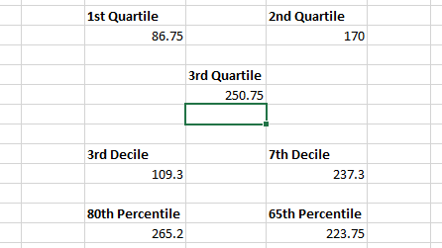

**Conclusions** –

1st Quartile deviation was found to be 86.75.

2nd Quartile deviation was found to be 170.

3rd Quartile deviation was found to be 250.75.

3rd Decile deviation was found to be 109.3.

7th Decile deviation was found to be 237.3.

80th Percentile deviation was found to be 265.2.

65th Percentile deviation was found to be 223.75.

--------------------------------------------------------------------------------------------

**Question 2**

The manager at a big restaurant has collected the information on the time take to process credit card payments by the counter at the counter staff. Find all the descriptive statistics using data analysis tool pack for this data.

1.57, 1.09, 1.13, 1.49, 0.98, 0.76, 1.40, 0.76, 1.38 ,1.29

1.59, 1.73, 2.31, 1.23, 1.89, 1.54, 1.97, 1.26, 0.27, 0.79

1.23, 1.56, 0.89, 1.78, 1.52, 1.07, 0.92, 1.38, 1.56, 1.98

* 1. , 4.89, 1.39, 1.76, 0.71 ,2.46, 0.89, 2.01, 3.21, 1.98

**Aim** - To obtain the quartiles, 3rd and 7th decile, and the 65th and 80th percentile for the given data.

**Procedure** –

1. List the given data in an Excel sheet.   
     
   A) Quartile.  
   1. To obtain the quartiles, use the ‘Quartile’ function, selecting the entire data as the array and then specify the desired quartile number.  
   2. The resultant formula will read ‘=QUARTILE(A1:A40, 1)’ for the first quartile, ‘=QUARTILE(A1:A40, 2)’ for the second quartile, and ‘=QUARTILE(A1:A40, 3)’ for the third quartile.  
     
   B) Deciles.  
   1. To obtain the deciles, use the ‘Percentile’ function, selecting the data as the array and then the specified decile represented as a decimal, i.e., the decile number divided by 10.  
   2. The resultant formula will read ‘=PERCENTILE(A1:A40, 0.3)’ for the third decile, and ‘=PERCENTILE(A1:A40, 0.7)’ for the seventh decile.  
   C) Percentiles.  
   1. To obtain the percentiles, use the ‘Percentile’ function, selecting the data as the array and then the specified percentile represented as a decimal, i.e., the percentile value divided by 100.  
   2. The resultant formula will read ‘=PERCENTILE(A1:A40, 0.65)’ for the sixty fifth percentile, and ‘=PERCENTILE(A1:A40, 0.8)’ for the eightieth percentile.

**Calculations** –

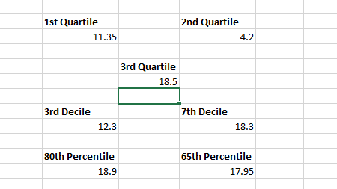

**Conclusions:**

1st Quartile deviation was found to be 11.35.

2nd Quartile deviation was found to be 4.2.

3rd Quartile deviation was found to be 18.5.

3rd Decile deviation was found to be 12.3

7th Decile deviation was found to be 18.3

80th Percentile deviation was found to be 18.9

65th Percentile deviation was found to be 17.95

---------------------------------------------------------------------------------------------------------------------------------

THE END

--------------------------------------------------------------------------------------------